PRACTICAL NO : 1

Aim : Study and Implementation of Infrastructure as a Service Theory :

Iaas is also known as Hardware as a Service (HaaS). It is one of the layers of the cloud computing platform. It allows customers to outsource their IT infrastructures such as servers, networking, processing, storage, virtual machines, and other resources. Customers access these resources on the Internet using a pay-as-per use model.

In traditional hosting services, IT infrastructure was rented out for a specific period of time, with pre-determined hardware configuration. The client paid for the configuration and time, regardless of the actual use. With the help of the IaaS cloud computing platform layer, clients can dynamically scale the configuration to meet changing requirements and are billed only for the services actually used.

Output

1. Go to Asure Portal Select Virtual Machine

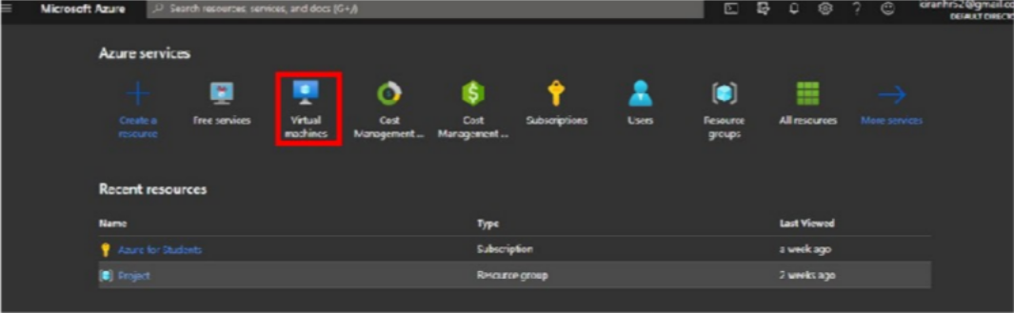

1. Create a Resource Group

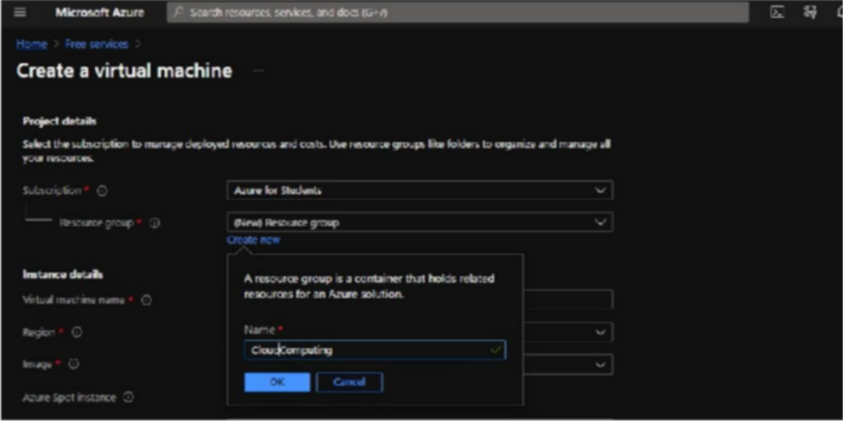

1. Select OS and Fill Other Necessay Information

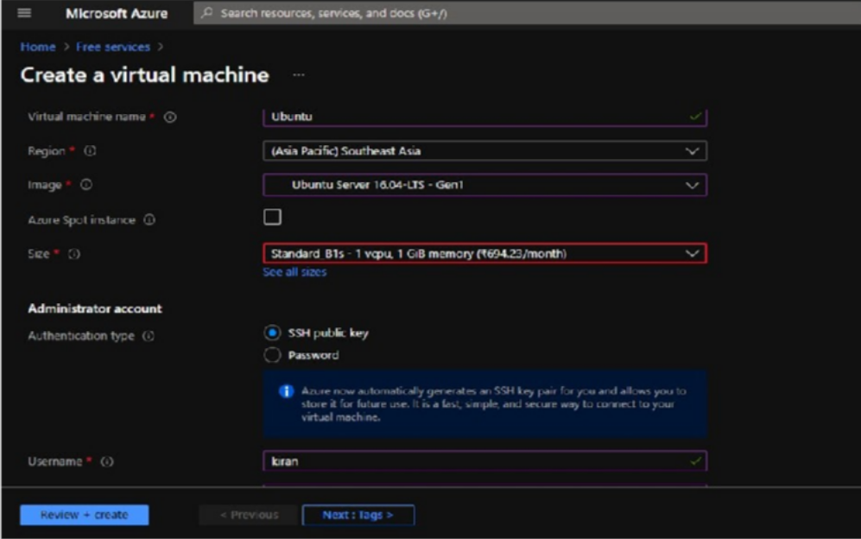

1. Generate a Public Key Using Putty Gen

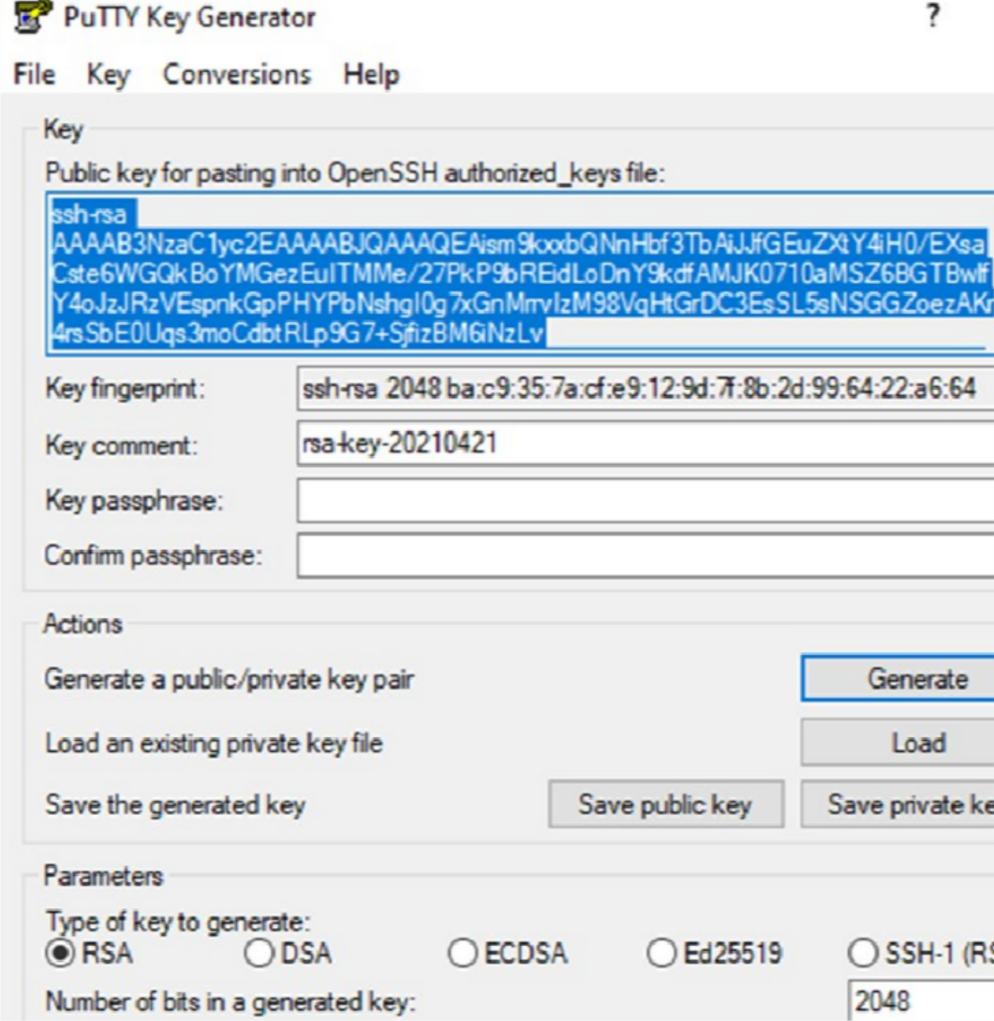

1. Now save the generated public and private key into your computer
2. Copy and paste the generated public key into azure portal and Click on Reviwe + create Button

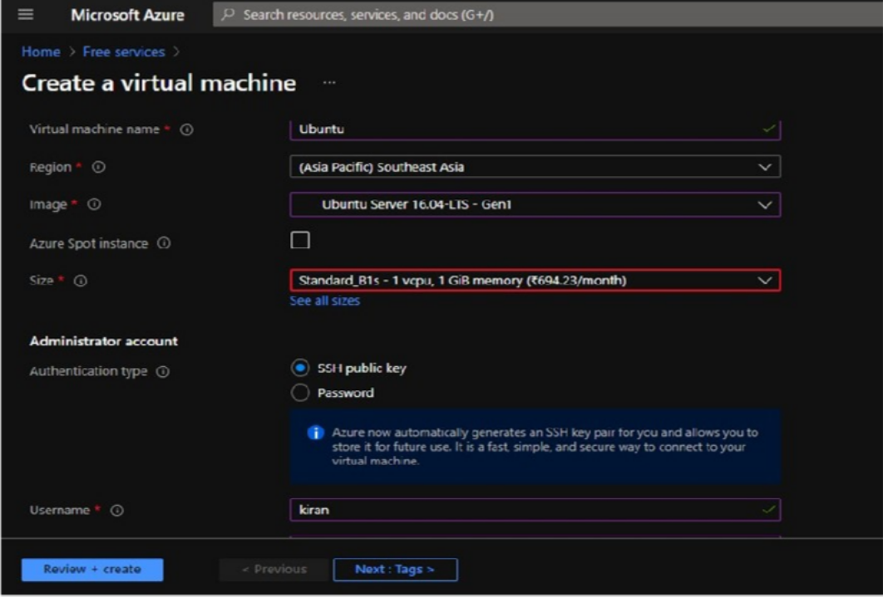

1. Click on Create Button

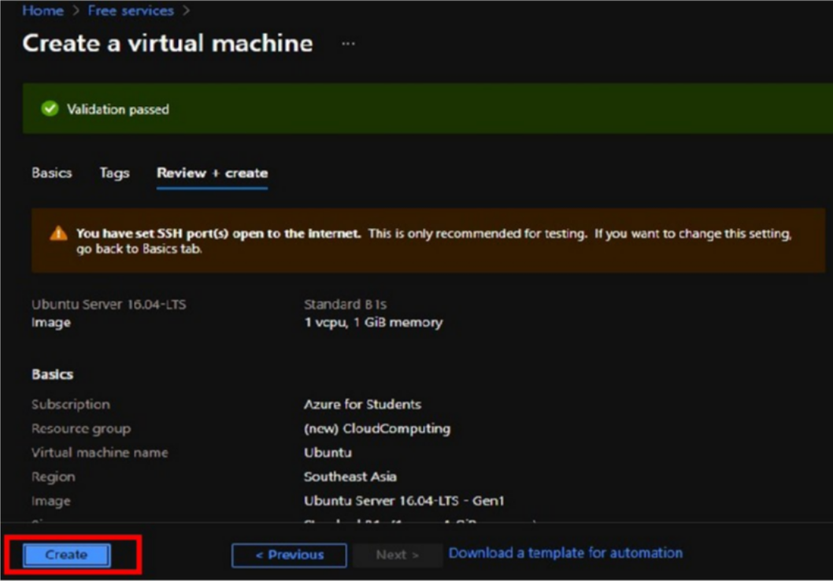

1. Our Virtual machine has been created . Now click on got resource

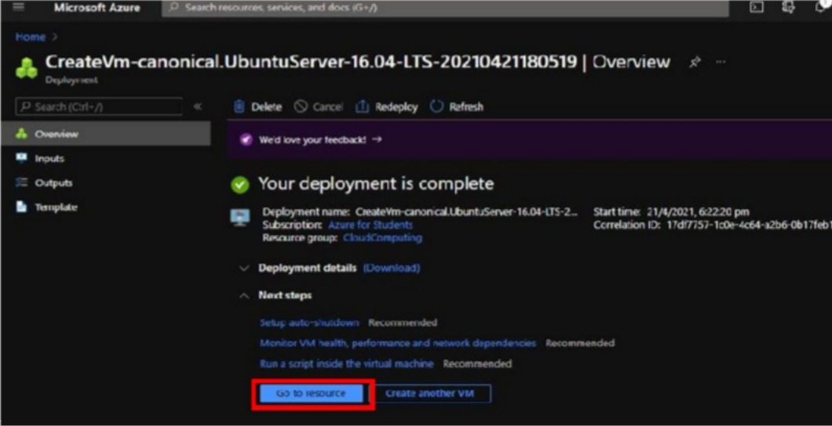

1. Copy the public IP of Your Machine and Paste in the putty software

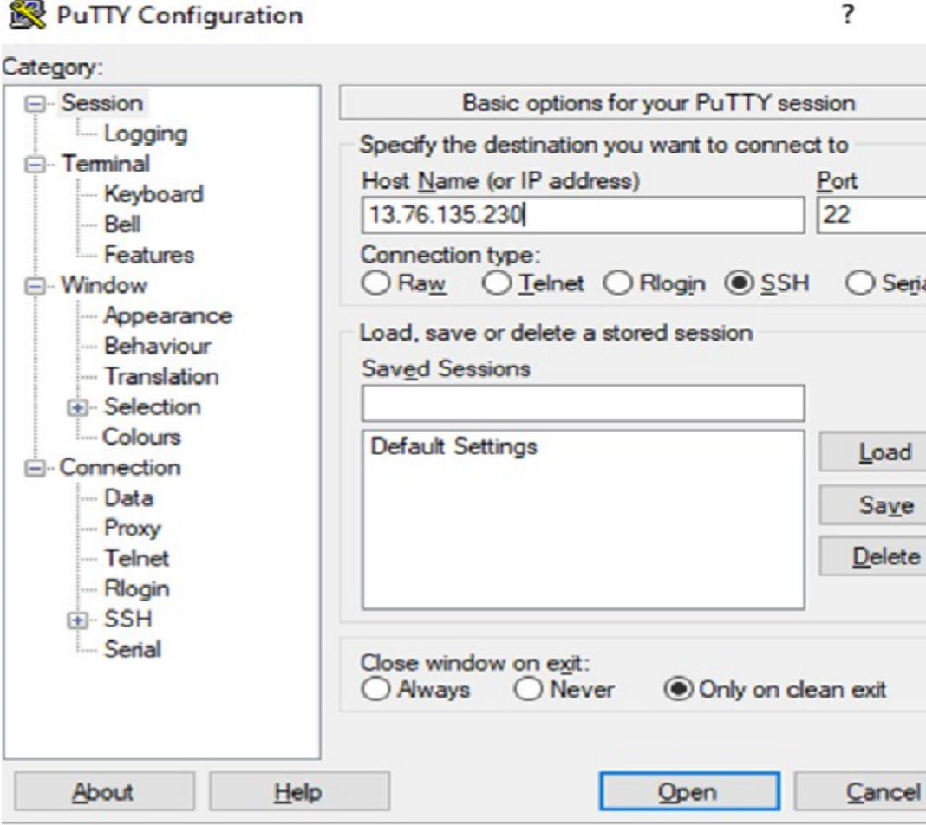

10 ) We have Successfully created the VM

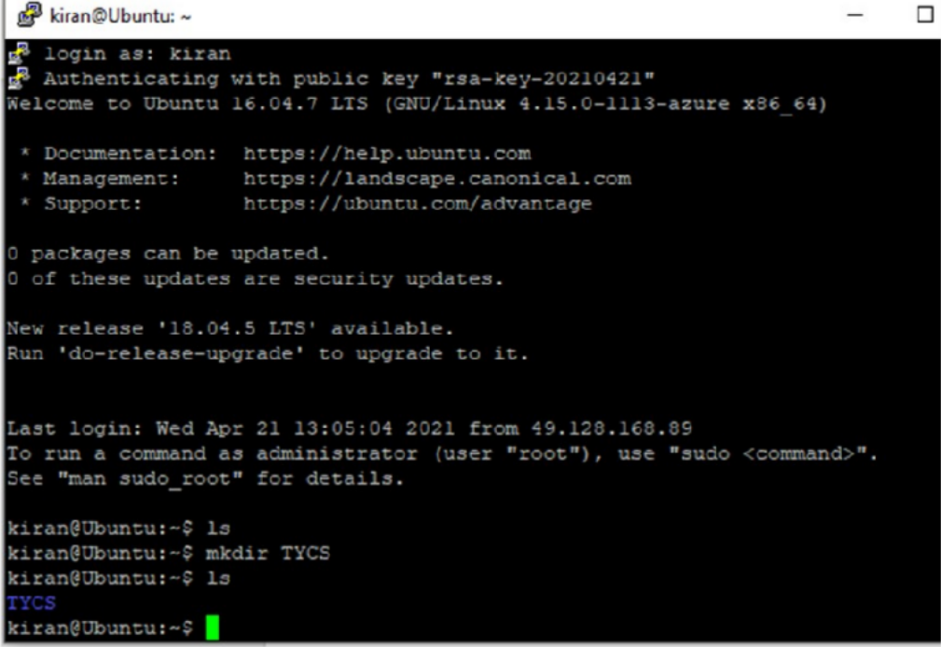

Conclusion : Successfully Performed Iaas